**UI Design Screenshots**

Below are the screenshots of my project “Agile Analytics” which was designed using Power BI.

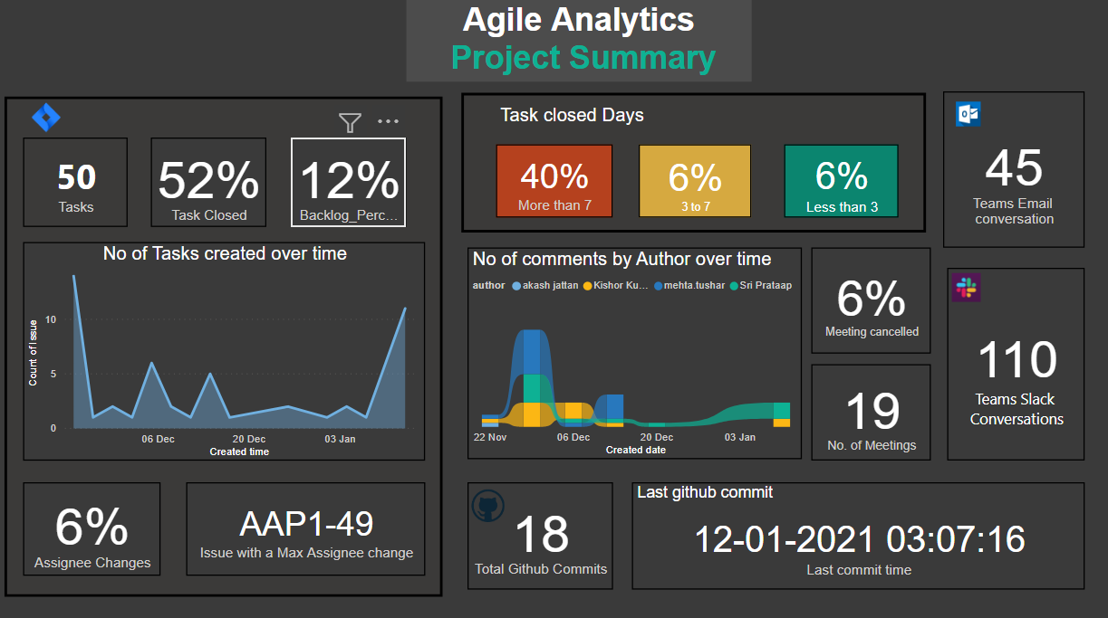

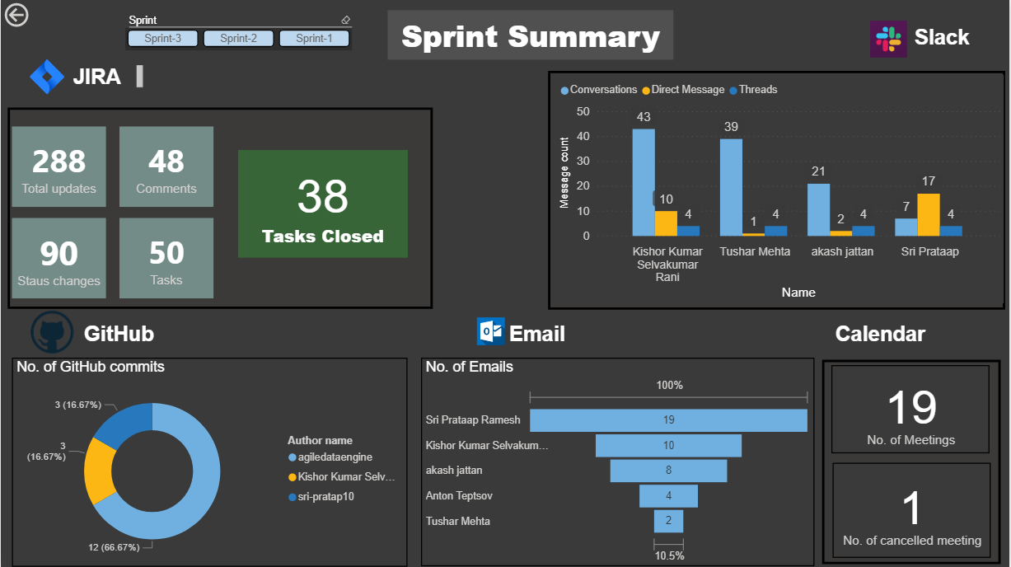

I have experience in Front-end using JavaScript, HTML, CSS and Angular working in my previous organization. Unfortunately, I did not have it on my GitHub.